Environment Notes for UPSC CSE GS3 by Pmfias.com

Contents
Solved Environment Prelims Questions (2011-15) 4
Environment 58
Habitat 58
Biosphere 59
Ecosystem 60
Components of an Ecosystem 62
Ecology 67
Ecotone 75
Ecological Niche 76
Functions Of Ecosystem 78
Ecological Succession 79
Homeostasis 84
Homeostasis in Ecosystem 86
Functions Of Ecosystem 86
Energy Flow Through an Ecosystem – Trophic Levels 87
Food Chain 88
Food Web 91
Biotic Interaction 92
Ecological Pyramids 96
Pollutants And Trophic Level 101
Biogeo Chemical Cycling or Nutrient Cycling 104
Nutrient Cycles 105
Carbon Cycle [Gaseous Cycle] 105
Nitrogen Cycle [Gaseous Cycle] 107
Phosphorus Cycle [Sedimentary cycle] 114
Sulphur Cycle [Sedimentary cycle] 116
Natural Ecosystem 117
Biomes or Terrestrial Ecosystems 118
Eutrophication – Algal Bloom 133
Harmful Algal Blooms 135
Aquatic Ecosystems 136
Wetland Ecosystem 140
Measures to Protect Wetlands 143
Ramsar Convention on Wetlands 143
Ramsar Sites in India 147
Wetlands International 153
National Wetlands Conservation Programme (NWCP) 154
Estuarine Ecosystem 156
India Estuarine Ecosystem 158
Mangroves 159
Environmental Degradation 164
Human Modified Ecosystems and Environmental Degradation 166
Environmental Issues in Himalayas 169
Soil erosion 174
Desertification 179
Pollution 182
Air Pollution 182
Classification of Pollutants 183
Prevention and Control of air Pollution 191
Government Initiative 196
Smog 198
Sulfurous smog 199
Photochemical smog 199
Effects of Smog 201
Question: UPSC Mains 2015 202
Ozone Hole – Ozone Depletion 203
Polar Vortex 206
Polar Stratospheric Clouds (PSCs) 206
Harmful Effects of Ozone Depletion 209
Measures to Prevent Ozone (O3) Layer Depletion 210
Acid Rain – Acidification 212
Ocean Acidification 219
Water Pollution 222
Causes of Water Pollution 223
Ground Water 228
Water Pollution Control Measures 231
Effects of Water Pollution 235
Water Conservation and Management 240
Radioactive Pollution 253
Impact Of Radiation From Mobile Phone Towers 259
Soil Pollution 260
Noise Pollution 263
Solid Wastes 264
Hazardous Waste 266
Electronic waste | E – WASTE 269
Heavy Metal Toxicity And Methods Of Their Prevention 273
Occupational Health Hazards 275
Treatment and disposal of solid waste 276
Environmental Impact Assessment 279
Biodiversity 291
Biodiversity of India 296
Wildlife Diversity Of India 300
Loss of Biodiversity 303
Man - Animal Conflict 306
Culling of animals – Conservation or Biodiversity loss? 306
Invasive Alien Species 310
Species Extinction 314
Biodiversity Conservation 315
Historic Citizen Movements to Conserve Biodiversity 324
Biodiversity Hot Spots 325
Indian Biodiversity Hot Spots 327
World Heritage Sites 329
International Union for Conservation of Nature 330
IUCN Red List or Red Data List or Red Book 333
2015 IUCN Red List India [As of April 24, 2016] 335
Steps Taken by the Government for Wildlife Protection 368
Insectivorous Plants 371
Insectivorous plants of India 372
Indian Vulture Crisis 375
Major Global Environmental Issues 381
Climate Change 381
Greenhouse Effect 382
Greenhouse Effect And Global Warming Due to Greenhouse Gases 382
Greenhouse Gases 383
Global Warming – Impacts 387
Some methods to reduce CO2 in atmosphere 388
Major International Conventions to Protect Environment 393
UNCED - Earth Summit 1992, Rio De janeiro Brazil 394
Convention on Biological Diversity 395
United Nations Convention to Combat Desertification (UNCCD) 397
UNFCCC: United Nations Framework Convention on Climate Change 398
Kyoto Protocol 400
Flexible Market Mechanisms – Kyoto Protocol 403
Important Summits Post Kyoto 407
Lima Summit, 2014 411
Paris summit, 2015 413
REDD & REDD+ 419
Intergovernmental Panel on Climate Change 420
Global Environment Facility 421
Transition to green economy 423
Arctic Council 424
India's National Action Plan On Climate Change 425
Indian Network On Climate Change Assessment 430
National Environmental Legislation 430
Pollution Related Acts 431
Environment and Biodiversity Related Acts 432
Acts for Protecting Coastal Environment and Wetlands 442
Green Revolution – Modern Agriculture 459
Second Green Revolution For Sustainable Livelihood 461
Concept Of Sustainable Agriculture 464
Methods Of Sustainable Agriculture 466
Biotechnology – Genetically Modified (GM) 478
Newer Agricultural Practices 481
Crop Classifications 485
Renewable & Non-Conventional Sources Of Energy 493
Ministry of New and Renewable Energy (MNRE) 503
Non-Renewable Sources Of Energy 506
Energy conservation 515
Solved Environment Prelims Questions (2011-15)

Solved Environment Prelims Questions (2011-15)
- The questions from the previous 3-4 years’ prelims papers help us understand the nature of questions asked in prelims and the trend the UPSC is following.
- Environment is the high priority topic for prelims and can be studied in relatively less hours compared to other subjects [Very High Cost to Benefit Ration].
Here I have not given explanation to location based question [Location of Biosphere reserves, Tiger reserves, National Parks etc.].
I will come up with a separate notes on Location Based Question that are important for Prelims under Geography and Environment.
Most of the questions below are explained in detail under respective headings.
If you found any mistakes, inform me at poormansfriend2485@gmail.com or My FB Page: https://www.facebook.com/PoorMansFriend2485
I advise you to first go through the full notes before trying to understand these questions.

2011-2012

Q1. Which one of the following is not a site for in-situ method of conservation of flora?
- Biosphere Reserves
- Botanical Garden
- National Park
- Wildlife Sanctuary
In situ conservation = on the site conservation without displacing the affected organism.
Ex situ conservation = conserving the organism in an artificial habitat by displacing it from its natural habitat.
Botanical Garden = Plants are bred in a protected environment far from their natural home, especially for research purposes. So its Ex situ conservation.
Rest all along with protected forests and reserved forests are In situ conservation methods.

Answer: b) Botanical Garden

Q2. What is the difference between the antelopes Oryx and Chiru?
- Oryx is adapted to live in hot and arid areas whereas Chiru is adapted to live in steppes and semi-desert areas of cold high mountains. .
- Oryx is poached for its antlers whereas Chiru is poached for its musk.
- Oryx exists in western India only whereas Chiru exists in north-east India only.
- None of the statements a, b, and c given above is correct.
They are both antelopes.
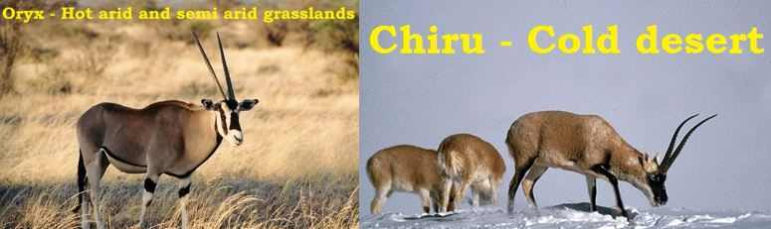

Answer: a)

Q3. Among the following States, which one has the most suitable climatic conditions for the cultivation of a large variety of orchids with minimum cost of production, and can develop an export oriented industry in this field ?
- Andhra Pradesh
- Arunachal Pradesh
- Madhya Pradesh
- Uttar Pradesh
Orchids are decorative flowering plants. They grow in regions with moderate climatic conditions [Sub-tropics with decent rainfall]
They are typical to North-Eastern states.
Great demand for these decorative flowering plants exists in South-East Asian region.

Answer: b)

Q4. Consider the following:
- Black-necked crane
- Cheetah
- Flying squirrel
- Snow leopard
Which of the above are naturally found in India ?
- 1, 2 and 3 only
- 1, 3 and 4 only
- 2 and 4 only
- 1, 2, 3 and 4
Black-necked crane is commonly found in Tibetan and trans-Himalayan region. In winters they migrate to less colder regions of Indian Himalayas.
Cheetah is an extinct species. They have gone extinct during pre-independence era. Reason: They were hunted down by various Indian kings and British officers.
Flying Squirrels are found in many Indian forests.
Snow leopard is an ‘endangered’ specie found in the Himalayan ranges.
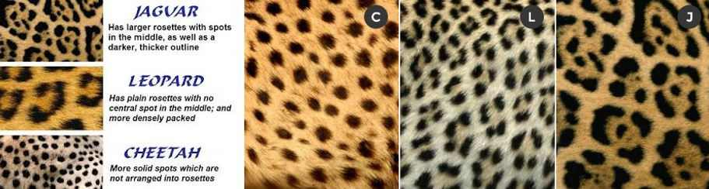

Answer: b) 1, 3 and 4 only

Q5. A sandy and saline area is the natural habitat of an Indian animal species. The animal has no predators in that area but its existence is threatened due to the destruction of its habitat. Which one of the following could be that animal?
- Indian wild buffalo
- Indian wild ass
- Indian wild boar
- Indian Gazelle
Sandy saline area = Kutch region
Indian wild buffalo = Terai region
Indian wild boar = can survive in different types of habitat: grasslands, taiga, tropical rainforests, but they prefer life in deciduous forests.
Chinkara (Indian gazelle) = Thar desert

Answer: b) Indian wild ass

Q6. Consider the following kinds of organisms

Habitat
- Habitat is the physical environment in which an organism lives (it corresponds to address of an organism).
- It is an ecological or environmental area inhabited by particular species of plants, animals, fungi, etc. Many habitats make up the environment.
- A single habitat may be common for more than one organism which have similar requirements.
- For example, a single aquatic habitat may support a fish, frog, crab, phytoplankton and many other kinds of organisms.
- The various species sharing a habitat thus have the same ‘address’. Forest, river etc. are other examples of habitat.
- All habitats are environments but all environments are not habitats.
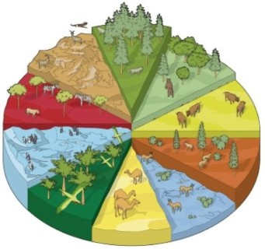

Difference between Habitat and Environment?
http://www.differencebetween.com/difference-between-habitat-and-vs-environment/
- A habitat always has life in it, whereas the environment does not necessarily have life in it.
- The habitat is a defined place or area of the environment according to the requirements of a particular life form. Therefore, a habitat is always an environment, but an environment is not always a habitat.
- A habitat is always a preference of one species, whereas an environment could be a preference of many species that could eventually become many habitats.
- Usually, the environment governs the properties of a habitat, but not vice versa.

Biosphere
- The biosphere is the biological component (supporting life) of earth which includes the lithosphere, hydrosphere and atmosphere.
- The biosphere includes all living organisms on earth, together with the dead organic matter produced by them.
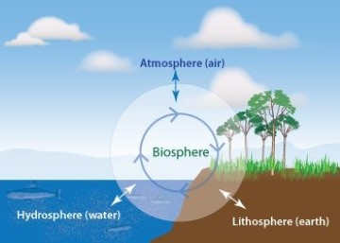
Picture Credits: https://briangrimmerblog.files.wordpress.com/2014/07/image.jpg
- Biosphere is absent at extremes of the North and South poles, the highest mountains and the deepest oceans, since existing hostile conditions there do not support life [Life is the characteristic feature of biosphere].
- Occasionally spores of fungi and bacteria do occur at great height beyond 8,000 metres, but they are metabolically inactive, and hence represent only dormant life.

Ecosystem
- An ecosystem can be visualised as a functional unit of nature, where living organisms [producers, consumers, and decomposers] interact among themselves and also with the surrounding physical environment.
- Ecosystem varies greatly in size from a small pond to a large forest or a sea.
- Forest, grassland and desert are some examples of terrestrial ecosystems; pond, lake, wetland, river and estuary are some examples of aquatic ecosystems. Crop fields and an aquarium may also be considered as man-made ecosystems.
- In the ecosystem, biotic and abiotic components are linked together through nutrient cycles and energy flows.
- An ecosystem can be of any size but usually encompasses specific and limited species. Eg: Aquatic Ecosystem. [This is how ecosystem is different from Environment]

Nitrogen Cycle [Gaseous Cycle]
- Apart from carbon, hydrogen and oxygen, nitrogen is the most prevalent element in living organisms.
- Nitrogen is a constituent of amino acids, proteins, hormones, chlorophylls and many of the vitamins. [All of these explained under Biology (http://imojo.in/76hnkb)]
- Plants compete with microbes for the limited nitrogen that is available in soil. Thus, nitrogen is a limiting nutrient for both natural and agricultural ecosystems.
- Nitrogen exists as two nitrogen atoms (N₂) joined by a very strong triple covalent bond (N ≡ N).
- In nature, lightning and ultraviolet radiation provide enough energy to convert nitrogen to nitrogen oxides (NO, NO₂, N₂O).
- Industrial combustions, forest fires, automobile exhausts and power-generating stations are also sources of atmospheric nitrogen oxides.
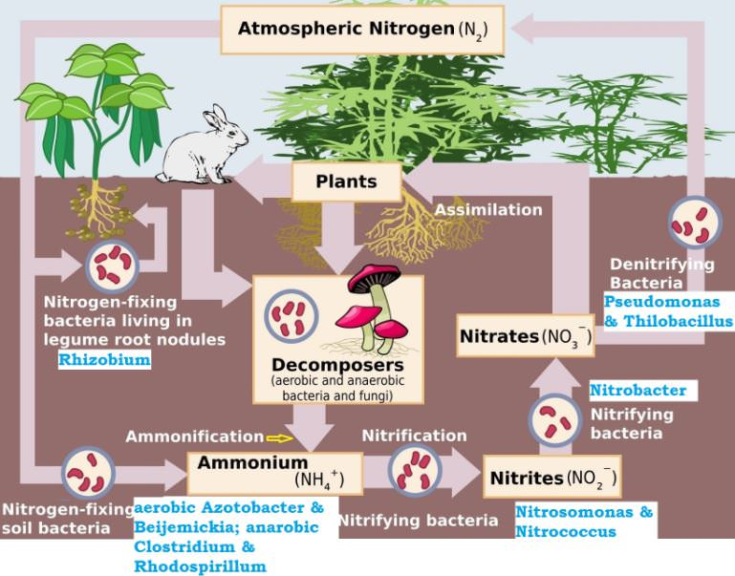

Nitrogen Fixing – Nitrogen to Ammonia (N₂ to NH₃)

Eutrophication – Algal Bloom
- Eutrophic water body: it is a a body of water rich in nutrients and so supporting a dense plant population, the decomposition of which kills animal life by depriving it of oxygen.
- Eutrophication is the response to the addition of nutrients such as nitrates and phosphates naturally or artificially, fertilizing the aquatic ecosystem.
- Algal blooms are the consequence of Eutrophication.
- Eutrophication occurs naturally due to deposition of nutrients [such as in depositional environments] carried by flood waters. It takes over centuries for eutrophication to occur naturally.
- Similar nutrient enrichment of lakes at an accelerated rate is caused by human activities [discharge of wastewaters or agricultural runoff, Combustion of fossil fuel (produces gases —nitrogen oxides), growing urban population in the coastal areas) and the consequent phenomenon is known as ‘cultural eutrophication’. It takes only decades.
- Phytoplankton (algae and blue-green bacteria) thrive on the excess nutrients and their population explosion covers almost entire surface layer. This condition is known as algal bloom.
- Oxygen in aquatic ecosystem is replenished by photosynthetic aquatic plants. Algal Blooms restrict the penetration of sunlight resulting in death of aquatic plants, and hence restricts the replenishment of oxygen.
- The oxygen level is already depleted due to the population explosion of phytoplankton.
- Phytoplankton are photosynthetic during day time adding oxygen to aquatic ecosystem. But during nights, they consume far more oxygen as they respire aggressively. i.e. Algal blooms accentuate the rate of oxygen depletion as the population of phytoplankton is very high.
- The primary consumers like small fish are killed due to oxygen deprivation caused by algal blooms.
- Death of primary consumers adversely effects the food chain and leads to the destruction of higher life forms.
- Further, more oxygen is taken up by microorganisms during the decomposition process of dead algae, plants and fishes. Due to reduced oxygen level, the remaining fishes and other aquatic organisms also die. All this eventually leads to degradation of aquatic ecosystem.
- The new anaerobic conditions [absence of oxygen] created promote growth of bacteria such as Clostridium botulinum which produces toxins deadly to aquatic organisms, birds and mammals.
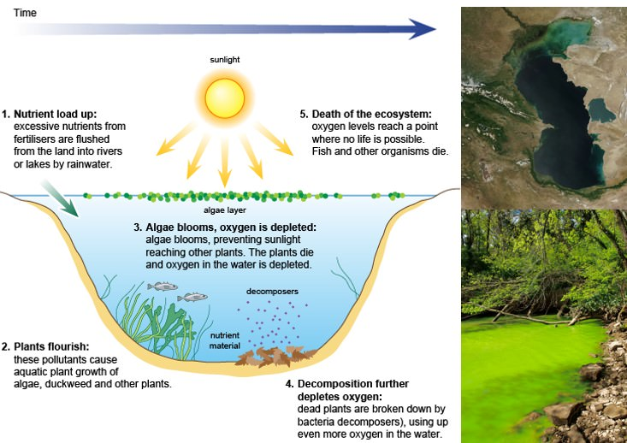

Effects of Eutrophication
- Loss of fresh water lakes: Eutrophication eventually creates detritus layer in lakes and produces successively shallower depth of surface water. Eventually the water body is reduced into marsh whose plant community is transformed from an aquatic environment to recognizable terrestrial [Lakes are one of the major sources of fresh water]
- New species invasion: Eutrophication may cause the ecosystem competitive by transforming the normal limiting nutrient to abundant level. This cause shifting in species composition of ecosystem.
- Toxicity: Some algal blooms when died or eaten, release neuro & hepatotoxins which can kill aquatic organism & pose threat to humans. E.g. Shellfish poisoning.
- Loss of coral reefs: Occurs due to decrease in water transparency (increased turbidity).
- Affects navigation due to increased turbidity; creates colour (yellow, green, red), smell and water treatment problems; increases biomass of inedible toxic phytoplankton, benthic and epiphytic algae and bloom of gelatinous zooplankton.

Estuarine Ecosystem
- An estuary is a place where a river or a stream opens into the sea (mouth of the river).
- It is a partially enclosed coastal area of brackish water (salinity varies between 0-35 ppt) with one or more rivers or streams flowing into it, and with a free connection to the open sea.
- At the estuaries, fresh water carrying fertile silt and runoff from the land mixes with the salty sea water.
- Estuaries form a transition zone (ecotone) between river environments and maritime environments.
- Examples of estuaries are river mouths, coastal bays, tidal marshes, lagoons and deltas.
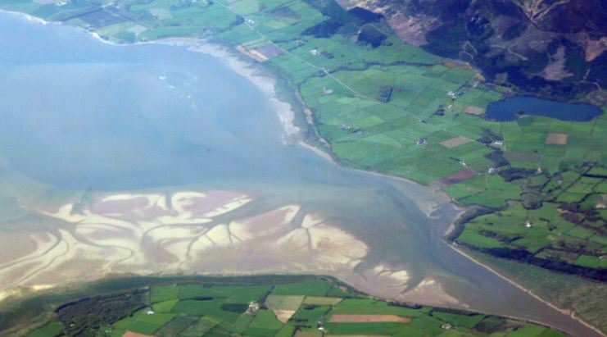
- Estuaries are formed due to rise in sea level, movement of sand and sandbars, glacial processes and tectonic processes.
- All the plants and animals in the estuaries are subjected to variations in salinity to which they are adapted (osmoregulation).
- Estuaries are greatly influenced by tidal action. They are periodically washed by sea water once or twice a day based on the number of tides.
- In some narrow estuaries, tidal bores are significant. Tidal bores cause great damage to the estuarine ecology.

Mangroves
- Mangroves represent a characteristic littoral (near the sea shore) forest ecosystem.
- These are mostly evergreen forests that grow in sheltered low lying coasts, estuaries, mudflats, tidal creeks backwaters (coastal waters held back on land), marshes and lagoons of tropical and subtropical regions.
- Mangroves grow below the high water level of spring tides. The best locations are where abundant silt is brought down by rivers or on the backshore of accreting sandy beaches.
- Mangroves are highly productive ecosystems and the trees may vary in height from 8 to 20 m. They protect the shoreline from the effect of cyclones and tsunamis.
- They are breeding and spawning ground for many commercially important fishes.
- Since mangroves are located between the land and sea they represent the best example of ecotone.
- Mangroves are shrubs or small trees that grow in coastal saline or brackish water.
- Mangroves are salt tolerant trees, also called halophytes, and are adapted to life in harsh coastal conditions.
- Mangrove vegetation facilitates more water loss. Leaves are thick and contain salt secreting glands. Some block absorption of salt at their roots itself.
- They contain a complex salt filtration system and complex root system to cope with salt water immersion and wave action.
- They are adapted to the low oxygen (anoxic) conditions of waterlogged mud.
- They produces pneumatophores (blind roots) to overcome respiration problem in the anaerobic soil conditions.
- Mangroves occur worldwide in the tropics and subtropics, mainly between latitudes 25° N and 25° S.
- They require high solar radiation to filter saline water through their roots. This explains why mangroves are confined to only tropical and sub-tropical coastal waters.
- Mangroves occur in a variety of configurations. Some species (e.g. Rhizophora) send arching prop roots down into the water. While other (e.g. Avicennia) send vertical “Pneumatophores” or air roots up from the mud.
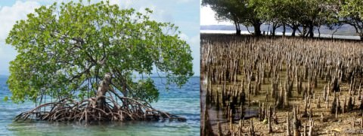
Prop roots and pneumatophores
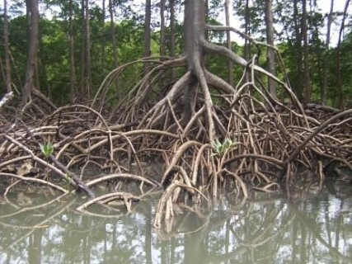
Stilt roots

Air Pollution
- Air pollution may be defined as the presence of any solid, liquid or gaseous substance including noise and radioactive radiation in the atmosphere in such concentration that may be directly and/or indirectly injurious to humans or other living organisms, property or interferes with the normal environmental processes.
- An ever increasing use of fossil fuels in power plants, industries, transportation, mining, construction of buildings, stone quarries had led to air pollution.
- Fossil fuels contain small amounts of nitrogen and sulphur. Burning of fossil fuels like coal (thermal power plants) and petroleum (petroleum refineries) release different oxides of nitrogen and sulphur into the atmosphere.
- These gases react with the water vapour present in the atmosphere to form sulphuric acid and nitric acid. The acids drop down with rain, making the rain acidic. This is called acid rain.
- Acid rain corrodes the marble monuments like Taj Mahal. This phenomenon is called as “Marble cancer”.
- Other kinds of pollutants are chlorofluorocarbons (CFCs) which are used in refrigerators, air conditioners and as pressurizing agents in aerosol sprays. CFCs damage the ozone layer of the atmosphere.
- The combustion of fossil fuels also increases the amount of suspended particles in air. These suspended particles could be unburnt carbon particles or substances called hydrocarbons.
- Presence of high levels of all these pollutants cause visibility to be lowered, especially in cold weather when water also condenses out of air. This is known as smog and is a visible indication of air pollution.

Classification of Pollutants
According to the form in which they persist after release into the environment.
- Primary pollutants: These persist in the form in which they are added to the environment e.g. DDT, plastic.
- Secondary Pollutants: These are formed by interaction among the primary pollutants. For example, peroxyacetyl nitrate (PAN) is formed by the interaction of nitrogen oxides and hydrocarbons.
According to their existence in nature
- Quantitative Pollutants: These occur in nature and become pollutant when their concentration reaches beyond a threshold level. E.g. carbon dioxide, nitrogen oxide.
- Qualitative Pollutants: These do not occur in nature and are man-made. E.g. fungicides, herbicides, DDT etc.

Measures to Prevent Ozone (O3) Layer Depletion

Monitoring of ozone layer is taken up by
- World Meteorological Organization (WMO)
- World Weather Watch (WWW)
- Integrated Global Ocean Services Systems (IGOSS)
- Global Climate Observing System (GCOS)

CFC substitutes
- Further, use of HCFCs (Hydrochloric fluorocarbons) as a substitute for CFCs is being recommended on temporary basis because HCFCs are relatively less damaging to ozone layer as compared to CFCs, but they are not completely ozone safe.

International Efforts
- Recognizing the deleterious effects of ozone depletion, an international treaty, known as the Montreal Protocol, was signed at Montreal (Canada) in 1987 (effective in 1989) to control the emission of ozone depleting substances.

Vienna Convention for the Protection of the Ozone Layer
- Multilateral Environmental Agreement.
- It was agreed upon at the Vienna Conference of 1985 and entered into force in 1988.
- It acts as a framework for the international efforts to protect the ozone layer.
- However, it does not include legally binding reduction goals for the use of CFCs, the main chemical agents causing ozone depletion. These are laid out in the accompanying Montreal Protocol.

Montreal Protocol
- The Montreal Protocol on Substances that Deplete the Ozone Layer (a protocol to the Vienna Convention for the Protection of the Ozone Layer) is an international treaty designed to protect the ozone layer by phasing out the production of numerous substances that are responsible for ozone depletion.
- It was agreed in 1987, and entered into force in 1989, followed by a first meeting in Helsinki, May 1989. Since then, it has undergone eight revisions.
- As a result of the international agreement, the ozone hole in Antarctica is slowly recovering.
- Climate projections indicate that the ozone layer will return to 1980 levels between 2050 and 2070.
- It is the single most successful international agreement to date.
The two ozone treaties (Vienna Convention and Montreal Protocol) have been ratified by 197 parties [196 UN states + European Union] making them the first universally ratified treaties in United Nations history.
UN Framework Convention on Climate Change is also ratified by 197 parties.

Q3. Which one of the following is associated with the issue of control and phasing out of the use of ozone-depleting substances?
- Bretton Woods Conference
- Montreal Protocol
- Kyoto Protocol
- Nagoya Protocol
Bretton Woods Conference established the International Bank for Reconstruction and Development (IBRD) and the International Monetary Fund (IMF).
Montreal Protocol is an international treaty to protect the ozone layer by phasing out the production of ozone depleting substances. It is legally binding.
Kyoto Protocol implemented the objective of the UNFCCC to fight global warming by reducing greenhouse gas concentrations in the atmosphere to “a level that would prevent dangerous anthropogenic interference with the climate system”. It is binding on the parties.
Nagoya Protocol is a supplementary agreement to the 1992 Convention on Biological Diversity (CBD) on “Access to Genetic Resources and the Fair and Equitable Sharing of Benefits Arising from their Utilization”.
Answer: b)

Radioactive Pollution

Sources

Artificial Sources of Radioactive pollution
- Accidents in nuclear power plants and nuclear waste.
- Nuclear weapon testing and explosion (Nuclear fallout). The fall Out contains radioactive substances such as strontium-90, cesium-137, iodine-131, etc.
- Uranium mining and mining of other radioactive material like thorium Uranium contamination is well observed in India.
- Radiation therapy and direct exposures to radiation for diagnostic purposes (e.g. X-rays), chemotherapy etc.
- The slow nuclear radiations can emanate from a variety of sources viz. nuclear reactors, laboratories, hospitals, and direct exposures to X-rays etc.

Natural Sources
- They include cosmic rays from space and terrestrial radiations from radio-nuclides present in earth's crust such as radium-224, uranium-238, thorium-232, potassium-40, carbon-14, etc.
- Some species of animals and plants preferentially accumulate specific radioactive, materials. For example, oysters deposit 65Zn, fish accumulate 55Fe, marine animals selectively deposit 90Sr.

Effects of Radioactive pollution
- The use of nuclear energy has two very serious inherent problems.
- accidental leakage, as occurred in the Three Mile Island, Chernobyl and Fukushima incidents and
- safe disposal of radioactive wastes. It has been recommended that storage of nuclear waste, after sufficient pre-treatment, should be done in suitably shielded containers buried within the rocks, about 500 m deep below the earth’s surface. However, this method of disposal is meeting stiff opposition from the public.
- The quick devastating and immediate effects of nuclear radiations are well known as witnessed following Hiroshima and Nagasaki in Japan during world war II.
- Continued small dose exposure to nuclear radiation can cause childhood leukemia, miscarriage, underweight babies, infant deaths, increased susceptibility to AIDS and other immune disorders and increased criminalities.
- Underground bomb testing releases radiations in very small doses of radicals that pollutes water and soil.
- This radioactive water is taken by plants through roots. The radioactivity enters food chain when such plants are eaten by animals and humans. Such radioactivity has been detected even in the milk.
- Radiation, that is given off by nuclear waste is extremely damaging to biological organisms, because it causes mutations to occur at a very high rate.
- At high doses, nuclear radiation is lethal but at lower doses, it creates various disorders, the most frequent of all being cancer.

Ionizing and Non-Ionizing Radiation
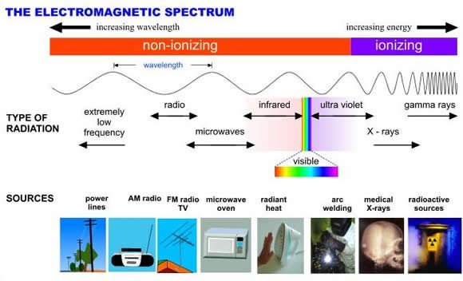
- Radioactivity is a phenomenon of spontaneous emission of proton (alpha-particles), electrons (beta-particles) and gamma rays (short wave electromagnetic waves) due to disintegration of atomic nuclei of some elements. These cause radioactive pollution.
- Radiations can be categorized into two groups namely the non-ionizing radiations and the ionizing radiations.

Non-ionizing radiations
- Non-ionizing radiations are constituted by the electromagnetic waves at the longer wavelength of the spectrum ranging from near infra-red rays to radio waves [include higher wavelength ultraviolet rays, microwaves].
- These waves have energies enough to excite the atoms and molecules of the medium through which they pass, causing them to vibrate faster but not strong enough to ionize them.
- In a microwave oven the radiation causes water molecules in the cooking medium to vibrate faster and thus raising its temperature.
- They may damage eyes which may be caused by reflections from coastal sand, snow (snow blindness) directly looking towards sun during eclipse.
- They injure the cells of skin and blood capillaries producing blisters and reddening called sunburns.

Ionizing radiations
- Ionizing radiations cause ionization (one or more electrons are pealed out from the outer shells of an atom) of atoms and molecules of the medium through which they pass.
Ionization is the process by which an atom or a molecule acquires a negative or positive charge by gaining or losing electrons to form ions, often in conjunction with other chemical changes.
- Electromagnetic radiations such as short wavelength ultra violet radiations (UV), X-rays and gamma rays and energetic particles produced in nuclear processes, electrically charged particles like alpha and beta particles produced in radioactive decay and neutrons produced in nuclear fission, are highly damaging to living organisms.
- Electrically charged particles produced in the nuclear processes can have sufficient energy to knock electrons out of the atoms or molecules of the medium, thereby producing ions.
- The ions produced in water molecules, for example, can induce reactions that can break bonds in proteins and other important molecules.
- An example of this would be when a gamma ray passes through a cell, the water molecules near the DNA might be ionized and the ions might react with the DNA causing it to break.
- They can also cause chemical changes by breaking the chemical bonds, which can damage living tissues.
- Short range effects include burns, impaired metabolism, dead tissues and death of the organisms.
- Long range effects are mutations increased incidence of tumors and cancer, shortening of life-span and developmental changes.
Non-ionizing radiations affect only those components which absorb them and have low penetrability.
Ionizing radiations have high penetration power and cause breakage of macro molecules.

IUCN Red List or Red Data List or Red Book
- The IUCN Red List of Threatened Species, founded in 1964, is the world's most comprehensive inventory of the global conservation status of biological species.
- When discussing the IUCN Red List, the official term “threatened” is a grouping of three categories: Critically Endangered, Endangered, and Vulnerable.
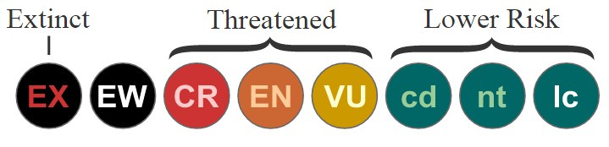
- The pink pages in this publication include the critically endangered species. As the status of the species changes, new pages are sent to the subscribers.
- Green pages are used for those species that were formerly endangered, but have now recovered to a point where they are no longer threatened.
- With passing time, the number of pink pages continue to increase. There are pitifully few green pages.

Species are classified by the IUCN Red List into nine groups
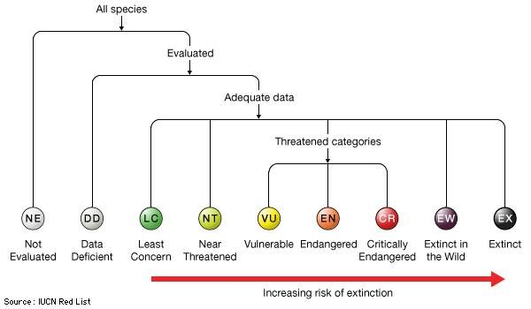
Picture Credits: http://media-2.web.britannica.com/
- Extinct (EX) – No known individuals remaining.
- Extinct in the wild (EW) – Known only to survive in captivity, or as a naturalized population outside its historic range.
- Critically endangered (CR) – Extremely high risk of extinction in the wild.

Criteria
- reduction in population (> 90% over the last 10 years),
- population size (number less than 50 mature individuals),
- quantitative analysis showing the probability of extinction in wild in at least 50% in their 10 years) and
- it is therefore considered to be facing an extremely high risk of extinction in the wild.
- Endangered (EN) – High risk of extinction in the wild.
- Vulnerable (VU) – High risk of endangerment in the wild.
- Near threatened (NT) – Likely to become endangered in the near future.
- Least concern (LC) – Lowest risk. Does not qualify for a more at-risk category. Widespread and abundant taxa are included in this category.
- Data deficient (DD) – Not enough data to make an assessment of its risk of extinction.
- Not evaluated (NE) – Has not yet been evaluated against the criteria.
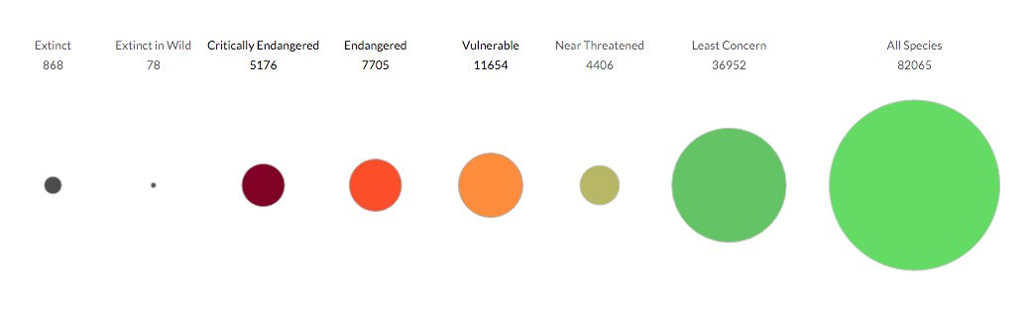
Pic Credits: https://upload.wikimedia.org/

The ‘Red Data Books’ published by the International Union for Conservation of Nature and Natural Resources (IUCN) contain lists of
- Endemic plant and animal species present in the biodiversity hotspots.
- Threatened plant and animal species.
- Protected sites for conservation of nature & natural resources in various countries.
Which of the statement given above is/are correct ?
- 1 & 3
- 2 only
- 2 & 3
- 3 only
IUCN is an NGO. It publishes Red data book which contains a list of ‘Threatened species’ (vulnerable, endangered and critically endangered).

Answer: b) 2 only

2015 IUCN Red List India [As of April 24, 2016]
- India has 988 species on IUCN ‘Red List’ as of 2015.
- India has added 15 more species to the “Red List” of threatened species [973 in 2014].
- The list contains critically endangered, endangered and vulnerable species.

‘Critically Endangered’ Mammals

Himalayan Brown/Red Bear (Ursus arctos isabellinus)
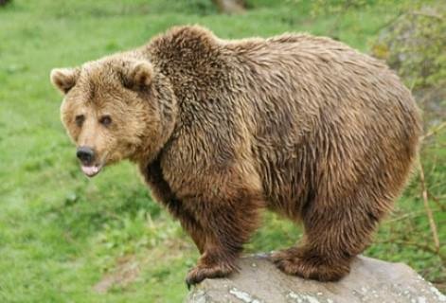
- Distribution: Nepal, Tibet, north India, and north Pakistan.
- Threats: loss of suitable habitat and persecution by humans.

Pygmy Hog (Porcula salvania)
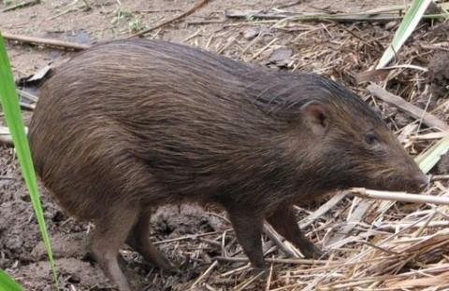
- Is the world's smallest wild pig. This species constructs a nest throughout the year.

Climate Change
- Climate is the long-term average of a region's weather events. The Earth's climate is not static. Over the billions of years of earth's existence, it has changed many times in response to natural causes like sun spot, ice age glaciations, etc.
- “Climate change” means a change of climate which is attributed directly or indirectly to human activity that alters the composition of the global atmosphere and which is in addition to natural climate variability observed over comparable time periods (100 years).
- Climate change is usually measured in major shifts in temperature, rainfall, snow, and wind patterns lasting decades or more.
- Humans are creating climate change by burning large amounts of fossil fuels (coal, oil, natural gas), deforestation (when forests are cut down or burned, they can no longer store carbon, and the carbon is released to the atmosphere).

Greenhouse Effect
- A greenhouse is a structure with walls and roof made chiefly of transparent material, such as glass, in which plants requiring regulated climatic conditions are grown.
- In a greenhouse, the incident solar radiation (the visible and adjacent portions of the infrared and ultraviolet ranges of the spectrum) passes through the glass roof and walls and is absorbed by the floor, earth, and contents, which become warmer and re-emit the energy as longer-wavelength infrared radiation (heat radiation).
- Glass and other materials used for greenhouse walls do not transmit infrared radiation, so the infrared cannot escape via radiative transfer.
- As the structure is not open to the atmosphere, heat also cannot escape via convection, so the temperature inside the greenhouse rises. This is known as the ‘greenhouse effect’.

Importance of Natural Greenhouse Effect
- The green-house effect is a natural phenomenon and has been occurring for millions of years on the earth.
- Life on the earth has been possible because of this natural greenhouse effect which is due to water vapour and small particles of water present in the atmosphere.
- Together, these produce more than 95 percent of total greenhouse warming.
- Average global temperatures is maintained at about 15°C due to natural greenhouse effect.
- Without this phenomenon, average global temperatures might have been around –17°C and at such low temperature life would not be able to exist.

Greenhouse Effect And Global Warming Due to Greenhouse Gases
- Atmospheric gases like carbondioxide, methane, nitrous oxide (N₂O), water vapour, and chlorofluorocarbons are capable of trapping the out-going infrared radiation from the earth’s surface. Thus, the temperature of the global atmosphere is increased.
[Oxides of Nitrogen with general formula NO_{x} – NO, NO2 – Nitrogen oxide, Nitrogen dioxide etc. are global cooling gasses while Nitrous oxide (N₂O) is a greenhouse gas]
- As this phenomenon of increase in temperature is observed in green houses, in the botanical gardens these gases are known as greenhouse gases and the heating effect is known as greenhouse effect.
- If greenhouse gases are not checked, by the turn of the century the temperature may rise by 5°C.
- Scientists believe that this rise in temperature will lead to deleterious changes in the environment and resulting in odd climatic changes (e.g. El Nino effect), thus leading to increased melting of polar ice caps as well as of other places like the Himalayan snow caps.
- Over many years, this will result in a rise in sea level that can submerge many coastal areas and lead to loss of coastal areas and ecosystems like swamps and marshes (most important ecosystems from the point of ecological services), etc.

Greenhouse Gases
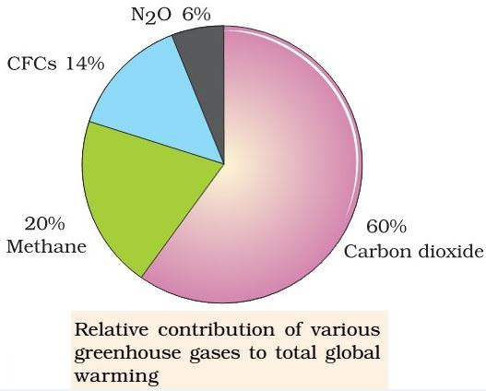
Gas | Sources and Causes
Carbon dioxide (CO₂) | Burning of fossil fuels, deforestation
Chlorofluorocarbons (CFCs) | Refrigeration, solvents, insulation foams, aero propellants, industrial and commercial uses
Methane (CH₄) | Growing paddy, excreta of cattle and other livestock, termites, burning of fossil fuel, wood, landfills, wetlands, fertilizer factories.
Nitrogen oxides (N₂0) | Burning of fossil fuels, fertilizers; burning of wood and crop residue.
Carbon Monoxide (CO) | Iron ore smelting, burning of fossil fuels, burning e-waste.

Some methods to reduce CO2 in atmosphere

Clean coal technology

Current Scenario
- Half of the world’s electricity is generated by burning coal.
- Coal will remain a dominant energy source for years to come.
- Since CO2 contributes to global warming, reducing its release into the atmosphere has become a major international concern.
- CO2 and CO (carbon monoxide) are the major greenhouse gas which are released during burning of coal.
- Along with the above gases, nitrogen oxides (destroys ozone) and sulphur oxides (acid rains) are also released.

Clean coal technology
- Clean coal technology seeks to reduce harsh environmental effects by using multiple technologies to clean coal and contain its emissions.
- Some clean coal technologies purify the coal before it burns.
- One type of coal preparation, coal washing, removes unwanted minerals by mixing crushed coal with a liquid and allowing the impurities to separate and settle.
- Other systems control the coal burn to minimize emissions of sulfur dioxide, nitrogen oxides and particulates.
- Electrostatic precipitators remove particulates that aggravate asthma and cause respiratory ailments by charging particles with an electrical field and then capturing them on collection plates.
- Gasification avoids burning coal altogether. With gasification, steam and hot pressurized air or oxygen combine with coal in a reaction that forces carbon molecules apart. The resulting syngas, a mixture of carbon monoxide and hydrogen, is then cleaned and burned in a gas turbine to make electricity.
- Wet scrubbers, or flue gas desulfurization systems, remove sulfur dioxide, a major cause of acid rain, by spraying flue gas with limestone and water.
- Low-NOx (nitrogen oxide) burners reduce the creation of nitrogen oxides, a cause of ground-level ozone, by restricting oxygen and manipulating the combustion process.

India’s coal
- Coal mined in India is a poor quality coal with less carbon, high ash (hard to dispose) and high moisture content (more gases; less fuel efficiency) [India’s coal is not Carboniferous Coal].
- To improve efficiency and reduce adverse effects, India should do away with its present sub-critical coal power plants and build more super-critical and ultra-super-critical ones (15-20% increase in efficiency).
- Should employ clean coal technology.

Carbon capture and storage
- Carbon capture and storage catches and sequesters (hide) carbon dioxide (CO2) from stationary sources like power plants.
- Capture: Flue-gas separation removes CO2 and condenses it into a concentrated CO2 stream.
- After capture, secure containers sequester the collected CO2 to prevent or stall its reentry into the atmosphere.
- The two storage options are geologic and oceanic (must hide the CO2 until peak emissions subside hundreds of years from now).
- Geologic storage involves injecting CO2 into the earth.
- Depleted oil or gas fields and deep saline aquifers safely store CO2 while coal seams absorb it.
- Ocean storage, a technology still in its early stages, involves injecting liquid CO2 into waters 500 to 3,000 meters deep, where it dissolves under pressure. However, this method would slightly decrease pH and potentially harm marine habitats.

Carbon Sink
- A carbon sink is a natural or artificial reservoir that accumulates and stores some carbon-containing chemical compound for an indefinite period.
- The process by which carbon sinks remove carbon dioxide (CO2) from the atmosphere is known as carbon sequestration.

Carbon Sink vs Carbon Source
- A carbon sink is anything that absorbs more carbon that it releases, whilst a carbon source is anything that releases more carbon than is absorb.
- Forests, soils, oceans and the atmosphere all store carbon and this carbon moves between them in a continuous cycle.
- This constant movement of carbon means that forests act as sources or sinks at different times.

Carbon sequestration
- Carbon sequestration is the process of capture and long-term storage of atmospheric carbon dioxide (CO2)
- It has been proposed as a way to slow the atmospheric and marine accumulation of greenhouse gases
- Carbon dioxide is naturally captured from the atmosphere through biological, chemical, or physical processes.
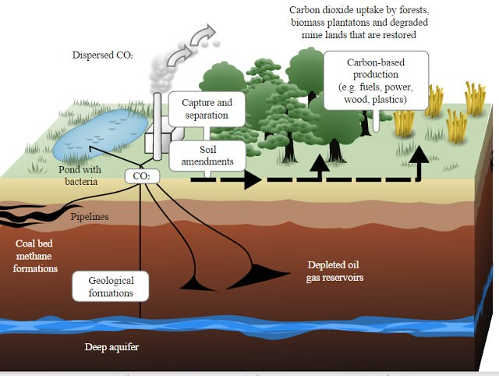

Forests as carbon Sinks
- Forests are carbon stores, and they are carbon dioxide sinks when they are increasing in density or area.
- In Canada's boreal forests as much as 80% of the total carbon is stored in the soils as dead organic matter.
- Tropical forests absorb about 18% of all carbon dioxide added by fossil fuels.
- In the context of climate change, the most important carbon stores are fossil fuel deposits as they have the unique benefit of being buried deep inside the earth, naturally separated from the carbon cycling in the atmosphere.
- This separation ends when humans burn coal, oil and natural gas, turning fossil carbon stores into atmospheric carbon.
- This release of carbon from fossil fuel has caused greenhouse gas (GHG) concentrations in the atmosphere to soar to levels more than 30 per cent higher than at the beginning of the industrial revolution.
- Because of this increase in atmospheric carbon, a lot of emphasis and hope has been put into the ability of trees, other plants and the soil to temporarily sink the carbon that fossil fuel burning releases into the atmosphere.
- Indeed, the Kyoto Protocol, the international communities’ main instrument for halting global warming suggests that the absorption of carbon dioxide by trees and the soil is just as valid a means to achieve emission reduction commitments as cutting carbon dioxide emissions from fossil fuels.

The scientific view is that the increase in global temperature should not exceed 2 °C above pre-industrial level. If the global temperature increases beyond 3°C above the pre-industrial level, what can be its possible impact/impacts on the world?
- Terrestrial biosphere tends toward a net carbon source
- Widespread coral mortality will occur.
- All the global wetlands will permanently disappear.
- Cultivation of cereals will not be possible anywhere in the world.
Select the correct answer using the code given below.
- 1 only
- 1 and 2 only
- 2, 3 and 4 only
- 1, 2, 3 and 4

Explanation:
Taiga and temperate forests act as an important carbon sink. Global warming by 3°C will turn these forests into carbon source.
Corals are very sensitive to temperature changes. 3°C rise in global temperature will lead to widespread coral mortality.
3°C rise in global temperature will lead to submergence of many low lying coastal wetlands (not all) due to rise in sea levels. Inland wetlands like Keoladeo Ghana National Park will not be effected (it is 100s of kilometers away from coast).
Because of the slow inertia, long response time for parts of the climate system, it has been estimated that we are already committed to a sea-level rise of approximately 2.3 metres (7.5 ft) for each degree Celsius of temperature rise within the next 2,000 years.
http://goo.gl/LH3RMl
Cultivation of cereals in tropics will take a hit. But in temperate regions their production increases in the short run.
Earth Summit 1992 - UNCED | CBD | UNCCD

Major International Conventions to Protect Environment

Nature conservation
- United Nations Conference On Environment And Development (UNCED) [This post]
- Convention on Biological Diversity (CBD) [This post]
- Ramsar Convention on Wetlands [Given in “Wetland Ecosystem”]
- Convention on International Trade in Endangered Species of Fauna and Flora (CITES) [Given in "IUCN Red List"]
- The Wildlife Trade Monitoring Network (TRAFFIC) [Given in "IUCN Red List"]
- Convention on the Conservation of Migratory Species (CMS)
- Global Tiger Forum (GTF)

Hazardous material [Given in “Solid Waste”]
- Stockholm Convention
- Basel Convention
- Rotterdam Convention

Land
- United Nations Convention to Combat Desertification (UNCCD) [This Post]

Marine environment
- International Whaling Commission (IWC)

Atmosphere
- Vienna convention and Montreal Protocol [Explained in “Ozone Depletion”]
- United Nations Framework Convention on Climate Change (UNFCCC) [Next Post]
- Kyoto Protocol [Next Post]

UNCED - Earth Summit 1992, Rio De janeiro Brazil
- Earth Summit 1992 is also known as The United Nations Conference on Environment and Development (UNCED).
- As a follow-up, the World Summit on Sustainable Development (Rio+10) was held in 2002 in Johannesburg, South Africa.
- 190 countries pledged their commitment to achieve by 2010, a significant reduction in the current rate of biodiversity loss at global, regional and local levels.
- In 2012, the United Nations Conference on Sustainable Development was also held in Rio, and is also commonly called Rio+20 or Rio Earth Summit 2012.

What is Rio+20 Conference, often mentioned in the news?
- It is the United nations Conference on Sustainable Development
- It is a Ministerial Meeting of the World Trade Organization
- It is a Conference of the Inter-governmental Panel on Climate Change
- It is a Conference of the Member Countries of the Convention on Biological Diversity
Answer: a) United nations Conference on Sustainable Development

The issues touched included
- checking production of toxic components, such as lead in gasoline, or poisonous waste including radioactive chemicals,
- alternative sources of energy to replace the use of fossil fuels,
- new reliance on public transportation systems in order to reduce vehicle emissions, congestion in cities,
- the health problems caused by polluted air and smoke, and
- the growing usage and limited supply of water.

Agenda 21
- Agenda 21 is an action plan of the United Nations (UN) related to sustainable development.
- It was an outcome of the United Nations Conference on Environment and Development (UNCED) held in Rio de Janeiro, Brazil, in 1992.
- The number 21 refers to an agenda for the 21st century.

Landmark Agreements
- An important achievement of the summit was an agreement on the Climate Change Convention which in turn led to the Kyoto Protocol and the Paris Agreement.
- Important legally binding agreements (Rio Convention) were opened for signature:
- Convention on Biological Diversity [This Post]
- United Nations Convention to Combat Desertification [This Post]
- Framework Convention on Climate Change (UNFCCC) [Next Post]
Biodiversity Related:

Convention on Biological Diversity
- Biodiversity knows no political boundaries and its conservation is therefore a collective responsibility of all nations.
- Convention on Biological Diversity (CBD) is a step towards conserving biological diversity or biodiversity with the involvement of the entire world.
- The historic Convention on Biological Diversity (Biodiversity Convention - a multilateral treaty) was opened for signature at the Earth Summit in Rio de Janeiro in 1992 and entered into in 1993.
- The convention called upon all nations to take appropriate measures for conservation of biodiversity and sustainable utilisation of its benefits.
- The Convention has three main goals:
- conservation of biological diversity (or biodiversity);
- sustainable use of its components; and
- fair and equitable sharing of benefits arising from genetic resources.
- It is often seen as the key document regarding sustainable development.
- The Convention is legally binding; countries that join it ('Parties') are obliged to implement its provisions.
- 195 UN states and the European Union are parties to the convention.
- All UN member states—with the exception of the United States—have ratified the treaty.
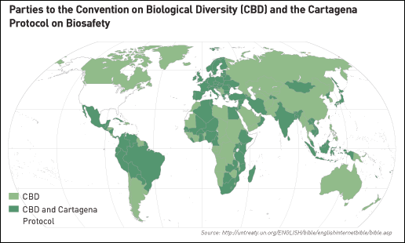
- At the 2010 10th Conference of Parties (COP) to the Convention on Biological Diversity in October in Nagoya, Japan, the Nagoya Protocol was adopted.

Cartagena Protocol
- CBD covers the rapidly expanding field of biotechnology through its Cartagena Protocol on Biosafety.
- It addresses technology development and transfer, benefit-sharing and biosafety issues.
- The Biosafety Protocol seeks to protect biological diversity from the potential risks posed by living modified organisms resulting from modern biotechnology.

Nagoya Protocol
- The Nagoya Protocol is a 2010 supplementary agreement to the 1992 Convention on Biological Diversity (CBD).
- The Nagoya Protocol is about “Access to Genetic Resources and the Fair and Equitable Sharing of Benefits Arising from their Utilization”, one of the three objectives of the CBD.
- It is the second Protocol to the CBD; the first is the 2000 Cartagena Protocol on Biosafety.

International Treaty on Plant Genetic Resources for Food and Agriculture
- Popularly known as the International Seed Treaty.
- International agreement in harmony with the Convention on Biological Diversity.
- Aims at guaranteeing food security through the conservation, exchange and sustainable use of the world's plant genetic resources for food and agriculture (PGRFA), as well as the fair and equitable benefit sharing arising from its use.

Consider the following international agreements:
- The International Treaty on Plant Genetic Resources for Food and Agriculture
- The United Nations Convention to Combat Desertification
- The World Heritage Convention
Which of the above has/have a bearing on the biodiversity?
- 1 and 2 only
- 3 only,
- 1 and 3 only
- 1, 2. and 3
World Heritage Convention explained in “Biodiversity”, Rest two in this section.

United Nations Convention to Combat Desertification (UNCCD)
- UNCCD is a Convention to combat desertification and mitigate the effects of drought through national action programs (NAP).
- NAP incorporate long-term strategies supported by international cooperation and partnership arrangements.
- The Convention stemmed from a direct recommendation of the Rio Conference's Agenda 21, was adopted in Paris, France in 1994 and entered into force in 1996.
- It is the only internationally legally binding framework set up to address the problem of desertification.
- The Convention is based on the principles of participation, partnership and decentralization—the backbone of Good Governance and Sustainable Development.
- It has 196 parties, making it truly global in reach.
- To help publicize the Convention, 2006 was declared "International Year of Deserts and Desertification".
- The UN Convention to Combat Desertification has established a Committee on Science and Technology (CST).
- CST is composed of government representatives competent in the fields of expertise relevant to combating desertification and mitigating the effects of drought.
- UNCCD collaborates closely with Convention on Biological Diversity (CBD).
UNFCCC - Kyoto Protocol - Carbon Credits Trading

UNFCCC: United Nations Framework Convention on Climate Change
- International environmental treaty that came into existence under the aegis of UN.
- Signed ==> May 1992.
- Location ==> New York City, USA.
- As of March 2014, UNFCCC has 196 parties (almost all countries).
- UNFCCC is negotiated at the United Nations Conference on Environment and Development (UNCED).
- UNCED is informally known as the Earth Summit 1992, held in Rio de Janeiro, Brazil.
- Role: UNFCCC provides a framework for negotiating specific international treaties (called "protocols") that aim to set binding limits on greenhouse gases.
- Objective of UNFCCC: Stabilize greenhouse gas concentrations in the atmosphere at a level that would prevent dangerous consequences.
- Legal Effect: Treaty is considered legally non-binding: The treaty itself set no binding limits on greenhouse gas emissions for individual countries.
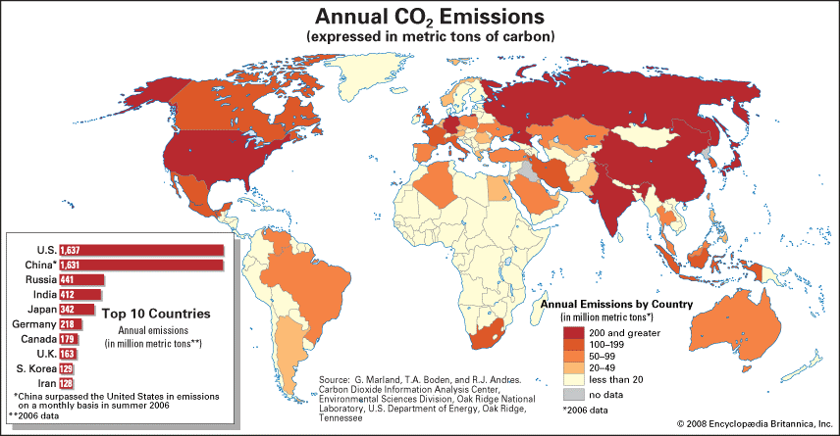

Second Green Revolution For Sustainable Livelihood
- The first Green Revolution was to ensure food security as there was severe scarcity of food in the country.
- The second Green Revolution aims at creating sustainable agriculture by leveraging advancements in technology.

Why we need Second Green Revolution
- With the growing population and over-exploitation of land resources, the pressure on food security will continue and rise.
- 65% of the population is still living in the villages and over 70% of the rural people are dependent on agriculture for their livelihood.
- Green Revolution, launched in mid-1960s, were mainly confined to certain areas. He said it was not successful in rain-fed areas, which contribute about 60% of the country's total food-grain production.
- The Green Revolution has made us self-sufficient in food grains but the environmental consequences and ecological costs are offsetting the progress made.
- The ground water is depleted and polluted. The lakes and ponds are becoming life less due to eutrophication – a direct consequence of Green Revolution.
- Growth in the agricultural sector has been almost stagnant.
- GM Crops are marred in various controversies related to intellectual property, ecological consequences, health consequences etc.
- Global warming is said to engulf productive coastal lands due to rise in sea levels. This creates an urgent need to raise agricultural productivity.
It is necessary to develop a suitable strategy to improve agricultural development in India.

What we want from Second Green Revolution
- Improving agricultural production while generating gainful self-employment for the small farmers and weaker sections of the society.
- Scaling up food production without disturbing the ecological balance.
- Boosting agricultural development, women empowerment and environmental protection. [Women are the major power in agriculture as about 65-70% of the labour in crop production is contributed by women].
- Reclaiming degraded and low fertile lands and lands deprived of irrigation.

Bringing Green Revolution in Eastern India (BGREI)
- Green Revolution that turned India from 'begging bowl' to leading producer of food-grains.
- BGREI is about binging similar benefits to eastern India that largely remained untouched of the wonder that converted the north-west into a ‘grain bowl’.
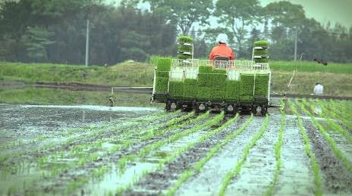
- BGREI is flagship programme under Rashtriya Krishi Vikas Yojana (RKVY).
- It is intended to address the constraints limiting the productivity of “rice based cropping systems”.
- The BGREI program was announced in the Union Budget, 2010-11.
- BGREI focuses on bringing the second Green Revolution in eastern region, which has rich water resources.
- Assam, Bihar, Chhattisgarh, Jharkhand, Odisha, West Bengal and eastern Uttar Pradesh (Purvanchal) are the seven states.

Objectives of BGREI
- Harness the water potential for enhancing agriculture production in Eastern India which was hitherto underutilized.
- Yield maximization of rice and wheat per unit area by improving agronomy, Water harvesting and conservation; and Water utilization (recycling of conserved water – surface water as well as groundwater).
- Promotion of recommended agriculture technologies and package of practices by addressing the underlying constraints.

Government Initiatives To Strengthen BGREI
- The ICAR has established IARI, Hazaribagh in Jharkhand and Indian Institute of Agricultural Biotechnology, Ranchi.
- It has also established National Research Centre for Integrated Farming at Motihari in Bihar to further strengthen the agricultural research for the eastern region.
- Central Agricultural University (CAU) has been sanctioned six new Colleges for the North- Eastern States.

How to Make Second Green Revolution a Success

