Biology NCERT Class 6-12 compilation for UPSC CSE Prelims by Pmfias.com
Biology is a Low Gain – High Pain topic (not of much use for mains; many topics to be covered, subject is complicated for a non-science student, weightage is not significant in prelims).
So, you should prepare Biology only after finishing Indian Polity, Economy, Modern History, Geography, Environment….. which have good weightage in both prelims and mains.

Contents
Cell 7
Cell Organelles 7
Plasma Membrane or Cell Membrane 8
Cell Wall 9
Cytoplasm 10
Nucleus 10
Prokaryotic Cells vs. Eukaryotic Cells 11
Vacuoles 13
Endoplasmic Reticulum (ER) 13
Golgi Apparatus or Golgi Complex 14
Mitochondria 14
Plastids 15
Summary 15
Plant Cell vs. Animal Cell 16
Biomolecule 18
Carbohydrates 19
Importance of Carbohydrates 23
Amino Acids 24
Proteins 25
Structure of Proteins 26
Enzymes 28
Primary and Secondary Metabolites 30
Vitamins 31
Deficiency Diseases 32
Micronutrients – Vitamins and Minerals 33
Food Sources of Vitamins and Minerals 35
Dietry Fibers 36
Fats 37
Lipid 38
Fatty Acid 38
Healthy Fats – Omega-3 and Omega-6, Monounsaturated and Polyunsaturated 39
Unhealthy Fats – Saturated Fat and Trans Fat 40
Adipose tissue 41
Metabolic Basis for Living 41
Animal Tissues 42
Epithelial Tissue 42
Connective Tissue 45
Muscular Tissue 47
Nervous Tissue 48
Human Digestive System 49
Digestive Glands 55
Digestion – Enzyme Action in Stomach 57
Digestion – Enzyme Action in Small Intestine 57
Absorption of Digested Products 58
Disorders of Digestive System 59
Respiration 60
Human Respiratory System 61
Mechanism of Breathing 62
Exchange of Gases 64
Transport of Gases 64
Regulation of Respiration 65
Disorders of Respiratory System 66
Endocrine Glands and Hormones 66
Hypothalamus 67
Pituitary Gland 67
Pineal Gland 68
Thyroid Gland 69
Parathyroid Gland 69
Thymus 70
Adrenal Gland 70
Pancreas 71
Testis 72
Ovary 72
Hormones of Heart, Kidney and Gastrointestinal Tract 72
Mechanism of Hormone Action 73
Neural Control and Coordination 75
Human Neural System 75
Human Brain 77
Reflex Action and Reflex Arc 78
Types of Movements 79
Muscular System – Muscle Types 80
Skeletal System 81
DNA 83
Chromosomes 83
Nucleotide and Nucleoside 84
Nucleic Acids 84
DNA and RNA 85
Biological Functions of Nucleic Acids – DNA and RNA 87
Recombinant DNA 87
Cell Cycle and Cell Division 88
Cell Cycle – Phases of Cell Cycle 89
Basic Phases of Cell Cycle – Interphase and M Phase or Mitosis 89
Interphase 90
Mitosis Phase or M Phase 91
Cytokinesis – Actual Cell Division 96
Significance of Mitosis 97
Meiosis 98
Meiosis I 99
Meiosis II 101
Significance of Meiosis 102
Mitosis – Meiosis Comparison 102
Mendel’s Experiments on Inheritance 104
Mendel’s Laws of Inheritance 109
Incomplete Dominance 110
Co-dominance 111
Inheritance of Two Genes - Dihybrid Cross 112
Law of Independent Assortment 113
Chromosomal Theory of Inheritance 115
Linkage and Recombination 116
Human Genome Project 117
Sex Determination 118
Sex Determination in Humans 120
Genetic Disorders 120
Microbes or Microorganisms 126
Diseases Caused by Microorganisms 127
Useful Microbes – Microbes In Human Welfare 132
Immunity 138
Innate Immunity 139
Acquired Immunity 139
Active and Passive Immunity 140
Vaccination and Immunization 141
Allergies 141
Auto Immunity 142
Immune System in the Body 142
AIDS – Acquired Immuno Deficiency Syndrome 144
Prevention of AIDS 146
Cancer 147
Drugs and Alcohol Abuse 149
Effects of Drug/Alcohol Abuse 150
Prevention and Control 151
Diseases Acute and Chronic Diseases 152
Communicable Diseases 153
Organ-Specific And Tissue Specific Diseases 153
Principles of Treatment 154
Principles of Prevention 156
Diseases in Indian Children 157
Some Other Diseases 159
Blood 160
Blood Vessels 160
Body Fluids and Circulation 160
Formed Elements 161
Coagulation of Blood 162
Lymph (Tissue Fluid) 162
Blood Groups 163
Circulatory System 165
Human Circulatory System 166
Cardiac Cycle 167
Electrocardiograph (ECG) 169
Double Circulation 170
Regulation of Cardiac Activity 170
Disorders of Circulatory System 171
Excretory System 173
Excretory Products and their Elimination 173
Human Excretory System 174
Urine Formation 177
Function of the Tubules 177
Mechanism of Concentration of the Filtrate 178
Regulation of Kidney Function 179
Micturition 180
Role of other Organs in Excretion 180
Disorders of the Excretory System 181
Origin Of Life on Earth 182
Evolution of Life on Earth 183
Biological evolution 184
A Brief Account of Evolution 185
Origin and Evolution of Man 188
Biodiversity 189
Classification of Biodiversity 190
Taxonomic Categories 191
Taxonomical Aids 193
Biological Classification 194
Biological Classification of Plants and Animals 196
Kingdom Monera 198
Kingdom Protista 200
Kingdom Fungi 202
Kingdom Plantae 205
Kingdom Animalia 205
Viruses, Viroids and Lichens 205
Plant Parts and Their Functions – Structural Organization in Plants 207
The Root 207
The Stem 208
The Leaf 209
The Flower 210
The Fruit 212
Transport Of Water And Minerals In Plants 212
Plantae 213
Plant Kingdom 214
Algae – Thallophytes 215
Bryophytes 218
Pteridophytes 219
Cryptogamae 220
Phanerogams – Plants with Seeds 220
Gymnosperms 220
Angiosperms 222
Kingdom Plantae - Summary 224
Plant Tissues 225
Meristematic Tissue 226
Permanent Tissue 227
Nutrition in Plants 232
Photosynthesis – Food Making Process In Plants 233
Saprotrophs – Fungi 235
Symbiosis 235
Parasites 236
Mineral Nutrition 236
Modes Of Reproduction in Plants 239
Asexual Reproduction in Plants 239
Sexual Reproduction in Plants – Unisexual and Bisexual 242
Asexual reproduction vs Sexual reproduction 244
Basis for Animal Kingdom Classification 244
Classification of Animal Kingdom 248
Phylum - Porifera 248
Phylum - Coelenterata (Cnidaria) 249
Phylum - Ctenophora 250
Phylum - Platyhelminthes 250
Phylum – Aschelminthes (Nemotoda) 251
Phylum - Annelida 252
Phylum - Arthropoda 253
Phylum - Mollusca 254
Phylum - Echinodermata 255
Phylum - Hemichordata 256
Phylum - Chordata 256
Phylum - Chordata 257
Division In Vertebrata 259
Basic Concepts 260
Class - Cyclostomata 261
Class - Pisces 262
Class - Amphibia 263
Class - Reptilia 264
Class - Aves 264
Class - Mammalia 265
Salient Features of Different Phyla in the Animal Kingdom 266
Reproduction In Animals 267
Sexual Reproduction 268
Asexual Reproduction 269
Human Reproductive System 269
Male Reproductive System 270
Female Reproductive System 271
Gametogenesis 273
Menstrual Cycle 275
Fertilisation And Implantation 277
In Vitro Fertilization 278
Pregnancy And Embryonic Development 278
Parturition And Lactation 279
Biotechnology 282
Biotechnology And Its Applications 285
Biotechnology: Ethical Issues 290
Notes Compiled by Pmfias.com from NCERT Science Textbooks Class 6-12.
Cell - Cell Organelles: Plasma Membrane, Cell Wall, Cytoplasm, Nucleus, Mitochondria. Prokaryotic Cells vs. Eukaryotic Cells. Plant Cell vs. Animal Cell.

Cell
Robert Hooke | Discovered and coined the term cell in 1665
Robert Brown | Discovered Cell Nucleus in 1831
Schleiden and Schwann | Presented The cell theory, that all the plants and animals are composed of cells and that the cell is the basic unit of life. Schleiden (1838) and Schwann (1839).
- With the discovery of the electron microscope in 1940, it was possible to observe and understand the complex structure of the cell and its various organelles.

Cell Organelles
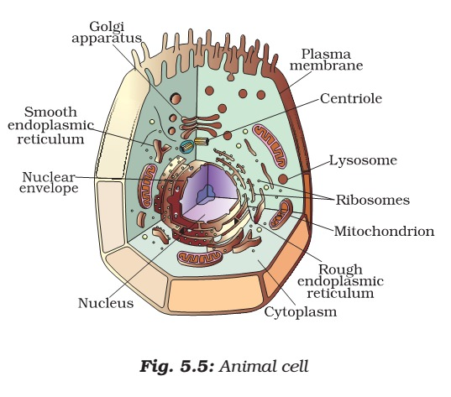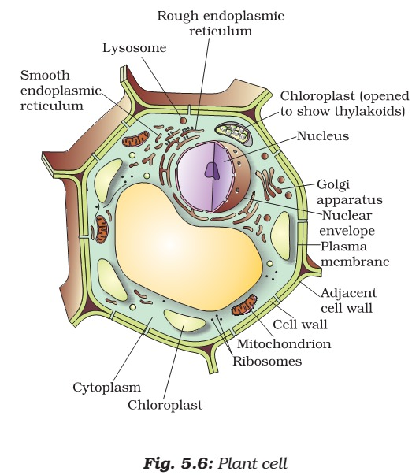

Plasma Membrane or Cell Membrane
- Cell membrane is also called the plasma membrane.
- It can be observed only through an electron microscope.
- Plasma membrane is the outermost covering of the cell that separates the contents of the cell from its external environment.

Endocytosis
- The plasma membrane is flexible and is made up of organic molecules called lipids and proteins.
- The flexibility of the cell membrane also enables the cell to engulf in food and other material from its external environment. Such processes are known as endocytosis (endo → internal; cyto → of a cell). Amoeba acquires its food through such processes.

Diffusion
- Plasma membrane is a selectively permeable membrane [The plasma membrane is porous and allows the movement of substances or materials both inward and outward].
- Some substances like carbon dioxide or oxygen can move across the cell membrane by a process called diffusion [spontaneous movement of a substance from a region of high concentration (hypertonic solution) to a region where its concentration is low (hypotonic solution)].
- Thus, diffusion plays an important role in gaseous exchange between the cells as well as the cell and its external environment.

Osmosis
- Water also obeys the law of diffusion. The movement of water molecules through a selectively permeable membrane is called osmosis.
- Osmosis is the passage of water from a region of high water concentration through a semi-permeable membrane to a region of low water concentration. Thus, osmosis is a special case of diffusion through a selectively permeable membrane.
- Unicellular freshwater organisms and most plant cells tend to gain water through osmosis. Absorption of water by plant roots is also an example of osmosis.
- Thus, diffusion is important in exchange of gases and water in the life of a cell. In additions to this, the cell also obtains nutrition from its environment.
- Different molecules move in and out of the cell through a type of transport requiring use of energy in the form of ATP.

Reverse Osmosis (RO)
- Reverse osmosis (RO) is a water purification technology that uses a semipermeable membrane to remove larger particles from drinking water.
- In reverse osmosis, an applied pressure is used to overcome osmotic pressure.
- Reverse Osmosis is a phenomenon where pure water flows from a dilute solution [hypotonic] through a semi permeable membrane to a higher concentrated solution [hypertonic].
- Semi permeable means that the membrane will allow small molecules and ions to pass through it but acts as a barrier to larger molecules or dissolved substances.

Cell Wall
- Cell wall is absent in animals.
- Plant cells, in addition to the plasma membrane, have another rigid outer covering called the cell wall. The cell wall lies outside the plasma membrane.
- The plant cell wall is mainly composed of cellulose. Cellulose is a complex substance and provides structural strength to plants.

Plasmolysis
- When a living plant cell loses water through osmosis there is shrinkage or contraction of the contents of the cell away from the cell wall. This phenomenon is known as plasmolysis (plasma → fluid; lysis → disintegration, decomposition).
- Only living cells, and not dead cells, are able to absorb water by osmosis. Cell walls permit the cells of plants, fungi and bacteria to withstand very dilute [hypotonic] external media without shrinkage.
- In such media the cells tend to lose water by osmosis. The cell shrinks, building up pressure against the cell wall. The wall exerts an equal pressure against the shrunken cell.
- Cell wall also prevents the bursting of cells when the cells are surrounded by a hypertonic medium (medium of high concentration).
- In such media the cells tend to gain water by osmosis. The cell swells, building up pressure against the cell wall. The wall exerts an equal pressure against the swollen cell.
- Because of their walls, plant cells can withstand much greater changes in the surrounding medium than animal cells.

Cytoplasm
- It is the jelly-like substance present between the cell membrane and the nucleus.
- The cytoplasm is the fluid content inside the plasma membrane.
- It also contains many specialized cell organelles [mitochondria, golgi bodies, ribosomes, etc].
- Each of these organelles performs a specific function for the cell.
- Cell organelles are enclosed by membranes.
- The significance of membranes can be illustrated with the example of viruses.
- Viruses lack any membranes and hence do not show characteristics of life until they enter a living body and use its cell machinery to multiply.

Nucleus
- It is an important component of the living cell.
- It is generally spherical and located in the center of the cell.
- It can be stained and seen easily with the help of a microscope.
- Nucleus is separated from the cytoplasm by a double layered membrane called the nuclear membrane.
- This membrane is also porous and allows the movement of materials between the cytoplasm and the inside of the nucleus [diffusion].
- With a microscope of higher magnification, we can see a smaller spherical body in the nucleus. It is called the nucleolus.
- In addition, nucleus contains thread-like structures called chromosomes. These carry genes and help in inheritance or transfer of characters from the parents to the offspring. The chromosomes can be seen only when the cell divides.
- Gene is a unit of inheritance in living organisms. It controls the transfer of a hereditary characteristic from parents to offspring. This means that your parents pass some of their characteristics on to you.
- Nucleus, in addition to its role in inheritance, acts as control center of the activities of the cell.
- The entire content of a living cell is known as protoplasm [cytoplasm + nucleus]. It includes the cytoplasm and the nucleus. Protoplasm is called the living substance of the cell.
- The nucleus of the bacterial cell is not well organized like the cells of multicellular organisms. There is no nuclear membrane.
- Every cell has a membrane around it to keep its own contents separate from the external environment.
- Large and complex cells, including cells from multicellular organisms, need a lot of chemical activities to support their complicated structure and function.
- To keep these activities of different kinds separate from each other, these cells use membrane-bound little structures (or ‘organelles’) within themselves.

Chromosomes
- The nucleus contains chromosomes, which are visible as rod-shaped structures only when the cell is about to divide.
- Chromosomes contain information for inheritance of features from parents to next generation in the form of DNA (deoxyribo nucleic acid)
- Chromosomes are composed of DNA and Protein.
- DNA molecules contain the information necessary for constructing and organizing cells. Functional segments of dna are called genes.
- In a cell which is not dividing, this dna is present as part of chromatin material. Chromatin material is visible as entangled mass of thread like structures. Whenever the cell is about to divide, the chromatin material gets organised into chromosomes.
- The nucleus plays a central role in cellular reproduction, the process by which a single cell divides and forms two new cells.
- It also plays a crucial part, along with the environment, in determining the way the cell will develop and what form it will exhibit at maturity, by directing the chemical activities of the cell.

Prokaryotic Cells vs. Eukaryotic Cells
- Organisms whose cells lack a nuclear membrane, are called prokaryotes (pro = primitive or primary; karyote ≈karyon = nucleus).
- Organisms with cells having a nuclear membrane are called eukaryotes.
- Prokaryotic cells also lack most of the other cytoplasmic organelles present in eukaryotic cells.
- Many of the functions of such organelles are also performed by poorly organised parts of the cytoplasm.
- The chlorophyll in photosynthetic prokaryotic bacteria is associated with membranous vesicles (bag like structures) but not with plastids as in eukaryotic cells.
Prokaryotes → defined nuclear region, the membrane-bound cell organelles are absent.
Eukaryotic Cells → have nuclear membrane as well as membrane-enclosed organelles.
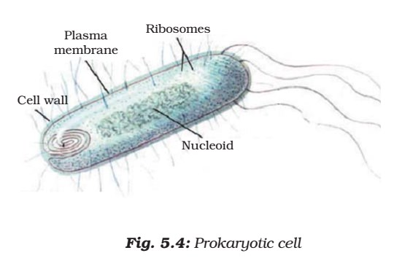
 | Prokaryotes | Eukaryotes
Organisms | Monera: Eubacteria and  Archebacteria | Protists, Fungi, Plants and Animals
Meaning of name | Pro = before  Karyon = nucleus | Eu = after  Karyon = nucleus
Evolution | 3.5 billion years ago (older type of cell) | 1.5 billion years ago
Uni-/multicellular | Unicellular (less  complex) | Multicellular (more complex)
Cell wall | almost all have cell walls (murein) | fungi and plants (cellulose and chitin): none in animals
Organelles | usually none | many different ones with specialized functions
Metabolism | anaerobic and aerobic: diverse | mostly aerobic
Genetic  material | single circular double stranded DNA | complex chromosomes usually in pairs; each with a single double stranded DNA molecule and associated proteins contained in a nucleus
Location of genetic information | Nucleoid region | Nucleus
Mode of  division | binary fission mostly; budding | mitosis and meiosis using a spindle: followed by cytokinesis

Nucleoid
- In some organisms like bacteria, the nuclear region of the cell may be poorly defined due to the absence of a nuclear membrane. Such an undefined nuclear region containing only nucleic acids is called a nucleoid.

